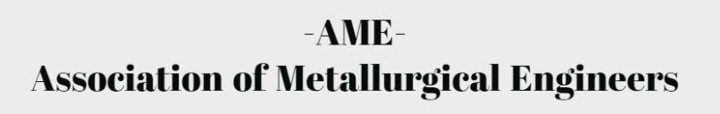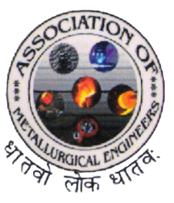
December 2017
Volume 3 Issue 1

JNTUH College of Engineering, Hyderabad
Department of Metallurgical Engineering
Thermochromic Liquid crystals.
Self-Healing Materials
Shape Memory Alloys
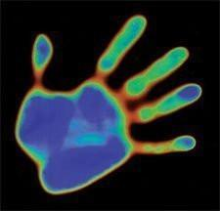
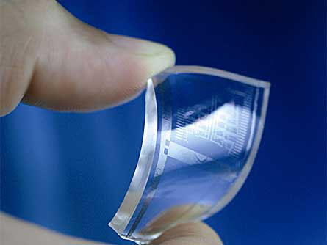
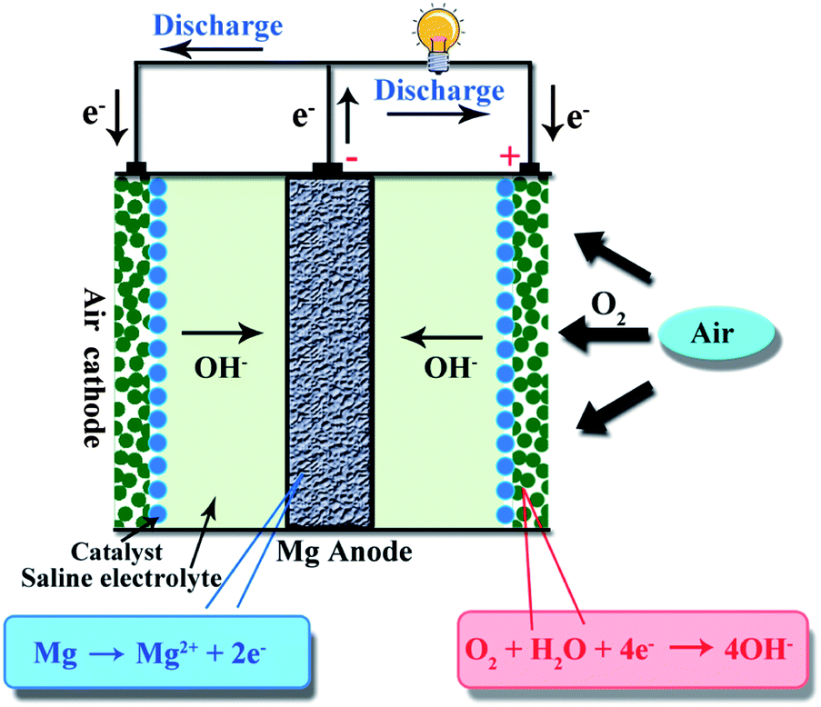
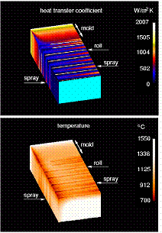
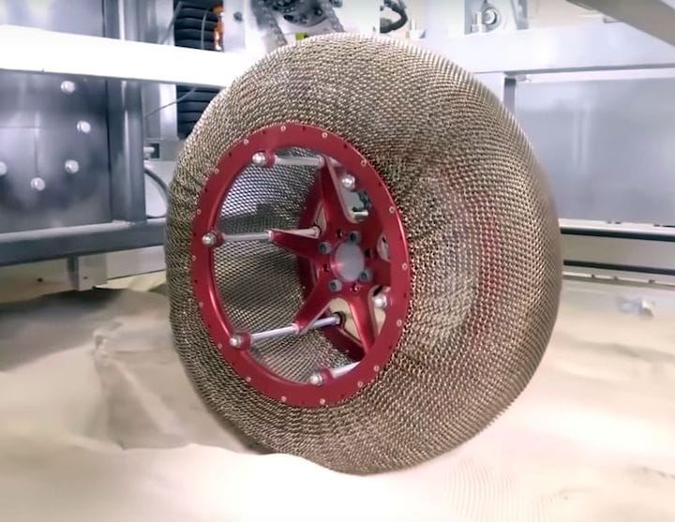
The Era of Smart Materials
VISION OF THE DEPARTMENT
To impart quality education in Metallurgical Engineering and constantly pursuing excellence by upgrading knowledge skills and attitude useful to Industry, Academic and Society.
MISSION OF THE DEPARTMENT
1. To produce graduates having professional excellence in Basic Sciences and Metallurgical Engineering with concern towards society.
2. To provide a scientific environment, to help meet the desires and needs of students and faculty for enhancing research efforts and technological innovations.
3. To provide technical support to higher education, industry and R&D units.
ABOUT THE DEPARTMENT
Welcome to the Department of Metallurgical Engineering of JNTU College of Engineering Hyderabad, where experienced faculties and highly motivated students - supported by a dedicated staffs - experience a unique engineering education.
The B.Tech in Metallurgical Engineering was started in 1989.The Department started functioning independently from 1992. Now the Department has a separate building shared with well-established labs. The Department is growing steadily and has its own Computer laboratory besides the Departmental Library. The department is also offering the following programmes, Ph.D – Part Time (Metallurgical Engineering), and PG - Part Time (Industrial Metallurgy) started in the year 2010.
Our faculty members have a passion for teaching and an avowed commitment to research and development. We are continually striving to improve the quality of our programs by finding new ways of structuring our curriculum and exploring new delivery methods.
We provide our students opportunities to engage in experiments, project work, industrial training, seminars, and team work to enhance the learning process that is so vital for a holistic engineering education. This new letter highlights the students and faculty achievements in the odd and even semester of academic year 2017-2018.

INSIDE
- Students sport achievements ….4
- Events attended/participated by students ….4
Technical Articles
- Smart Materials for New Generation ….5
- Smart Materials; Applications. ….6
SMRUTHI 2017 ….8

Events and Lectures Conducted in the Department:
S.No | Event | Date | Descriptions
1. | SMRUTHI | 9/10/2017 | 125-150 students participated  Cricket, basket ball, volleyball, throw ball, chess, caroms sports events conducted.
2. | Expert Lecture on Synthesis of Multi Component Alloy Using Mechanical Alloying | 21.10.2017  Dr. R. Kotaiah  Director  Marri Educational Society, Hyd. | 60 students participated.
Events attended/participated by students:
- Quiz Competition on “Role of Engineers in Developing India” which was conducted by The Institution of Engineers (India), Telangana State Centre, Hyd. and Government of Telangana on the occasion of 15th Sep 2017, 50th Engineers Day in Commemoration of 157th Birthday Celebrations of Bharat Ratna Sir Mokshagundam Visvesvaraya.
5 stundets have participated.

1 | 15011A0619 | Md. Arif Uddin | II year B.Tech.
2 | 15011A0620 | M. Niharika
3 | 15011A0609 | K.Chandrika
4 | 15011A0616 | D. Karthik
5 | 15011A0626 | B. Prema Sai Goud

-Technical Articles-
1. Smart Materials – For New Generation
“The need for new generation of advanced materials in modern applications has led to the development of the smart materials”.
The idea of smart materials originated in mid – 1980s. The main perception of smart materials is ability to be clever, active and sophisticated.
Smart materials are unique in that they exhibit different properties when there is change in their environment. They react to changes in their environment. They react to changes in temperature, stress, moisture, pressure, light, electric or magnetic field. This peculiar property makes them useful for certain applications.
The degree of smartness is dictated by their responsiveness to environmental stimuli. Structures that are made from smart materials are referred to as smart structures.
Smart materials have one or more properties that can be dramatically altered. Most everyday materials have physical properties, which cannot be significantly altered; for example if oil is heated it will become a little thinner, whereas a smart material with variable viscosity may turn from a fluid which flows easily to a solid. A variety of smart materials already exists, and is being researched extensively. These include shape memory alloy, piezoelectric material, electro active polymer (EAP), Magnetostrictive material etc.
Finally smart materials are able to sense and respond to environment around them and have the potential to improve existing technology and add new functionality to products. They have applications in a wide variety of areas and have an important role in waste reduction. Thus we conclude that there is an important role of smart materials in our life.
M. NIHARIKA( 15011A0620)

- Smart Materials
Smart materials are materials that have one or more properties that can besignificantly changed in a controlled fashion by external stimuli, such as stress, temperature, moisture, pH, electric or magnetic fields.
Such materials have the ability to change shape or size simply by adding a little bit of heat, or to change from a liquid to a solid almost constantly and associated changeable physical properties as shape, stiffness, damping etc., these materials are called smart materials.

HISTORY OF SMART MATERIALS
- Most of the smart materials have been discovered around 50 years ago, but they were not exploited to get the benefits which they possess.
- There is now a huge variety of smart materials with different special properties that make a particular material well suited to all types of applications.
- In 1930, Arne Olander was first observed the shape memory effect while working with an alloy of gold and cadmium
- In 1932, the first recorded observation of smart material transformation was made on gold-cadmium
- In 1938, the phase transformation was observed in brass(copper-zinc) and Au-cd alloy was plastically deformed when cold but returns to its original configuration when heated.
- In 1962, the shape memory properties of Ni-Ti alloys were discovered and pure Ni-Ti has very low ductility in the martensitic phase, the properties can be modified by the addition of a small amount of a third element. These groups of alloys are known as NITINOL(Nickel-Titanium-Naval-Ordance-Laboratories).
- After this, a number of other alloy systems with the shape memory were found.

TYPES OF SMART MATERIALS
There are a number of types of smart material, some of which are already common. Some examples are as following:
Piezoelectric materials: - These are materials that produce a voltage when stress isapplied. Since this effect also applies in the reverse manner, a voltage across the sample will produce stress within the sample. Suitably designed structures made from these materials can therefore be made that bend, expand or contract when a voltage is applied. Some popularly known piezoelectric materials are: Quartz, Aluminum Nitride, lead.
Shape Memory Alloys :- These are Thermo-responsivematerials where deformation can be induced and recovered through temperature changes. Regain original shape when heated and super elastic behavior in high temperature.
Magnetic Shape Memory Alloys :- There alloys are materials that change their shape in responseto a significant change in the magnetic field. Some are cobalt, Terfenol-D.
pH- sensitive Polymers :- These are materials which swell/collapse when the pH of thesurrounding media changes. There are two kinds of pH sensitive materials: acidic group(-COOH, -SO₃H) and polymeric acid.
Holochromic Materials :- There are commonly materials that change their color as a result of changing acidity. One suggested application is for paints that can change color to indicate corrosion in the metal underneath them.
Non-Newtonian Fluid :- This is a liquid which changes its viscosity in response to anapplied shear rate. In other words the liquid will change its viscosity in response to some sort of force or pressure. Another good example is Custard, as long as it is starch based.
Self-Healing Materials :- These are materials that have ability to heal after being wounded. Self-healing materials have the natural ability to repair damage due to abnormal usage and so increase the material’s useful lifetime.
SOME INTERESTING SMART MATERIALS
- ARTIFICIAL CILIA
  - Artificial cilia (copolymer film with hair like structures) which changes its color and structure in different conditions.
  - It results of molecular rearrangements and conformational shifts in the structure of the copolymers.
  - In HCl environment, it turns yellow to red.
  - In interaction with Ammonium hydroxide vapors, it backs to original.
- INTELLIGENT GLASS
  - It selectively reflects the infrared on hot days
  - The secret is a super-thin coating of vanadium oxide molecules doped with tungsten.
  - At low temperatures, vanadium dioxide is transparent to infrared.
  - At higher temperatures, the bonding between the molecules change and material becomes reflective , like a metal.

FUTURE OF SMART MATERIALS

- The development of true smart materials at the atomic scale is still some way off, although the enabling technologies are under development.
- These require novel aspects of nanotechnology (technologies associated with materials and processes at the nanometer scale, 10-9m) and the newly developing science of shape chemistry.
- Materials and structures which respond to their environment, including their human owners, is a somewhat alien concept.
- Now in future new ECO-FRIENDLY smart materials are developed for reducing the harmful effect of some smart materials.
R. RANJAN PRASAD(15011A0654)

SMRUTHI 2017
Smruthi is a college wide sports event conducted in the memory of Late. M. Swathi who was a student of metallurgical engineering at JNTUHCEH. She passed away due to a viral fever. She was a talented individual and worked hard to get an admission into JNTUHCEH, her dream was to become a successful metallurgist. The department of Metallurgical Engineering remembers her efforts and dedication towards education and conducts SMRUTHI in the month of October ever year. This event is dedicated to raise awareness on health and hygiene amongst the youngster and students on JNTUH. The department is conducting events like sports, extra-curricular activities and helps the orphans with the money raised thru these actives, and conducting blood bank donation camps.
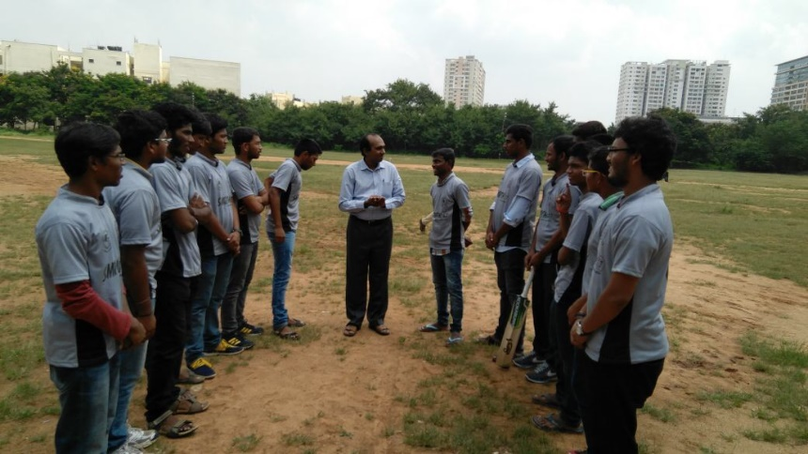

Dr. B. Ramersh Chandra, faculty member tossing the coin for cricket event- Smruthi 2017

